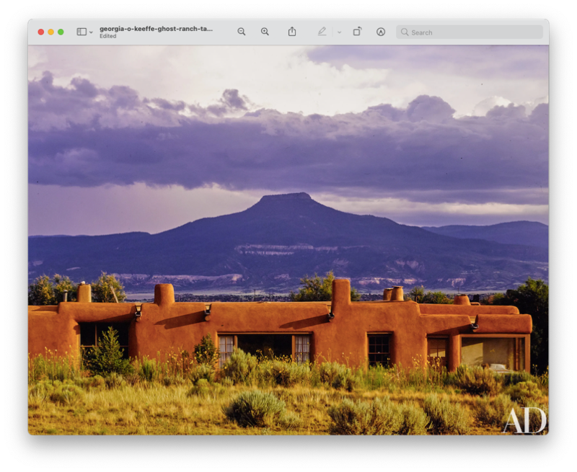**Ghost Ranch Retreat**

**May 18 – 21, 2025**

**With William**

**303-960-5177**

**WilliamMallingBoulder@gmail.com  
Hi Folks,**

**Yoga Retreat with William May 18 - 21, 2025 at Ghost Ranch, Abiquiu, New Mexico!**

**Stunning western experience in the southwest, featuring its own box canyon. Historical note: Past home of Georgia O’Keefe.**

**Take time to take care of yourself, especially these days.  Be with good folks, rejuvenate, relax, and connect with the wind and wilderness!  Have some great meals together.  Time alone, time together.**

**Retreat includes:**

**- Six Yoga Classes. In a beautiful yoga room.**

**- Lodging**

**- Hikes.**

**- One Night Dinning out. (extra cost)**

**- Nighttime campfires, and Much More.**

**Basic Costs Lodging and Retreat:   (3 Nights)**

**- $675 for Double Occupancy Room Private Bath. (2 people a in room 2 queen beds.)**

**- $600 for Semiprivate Room Shared Bath.  (4 people, 2 in a room, 4 queen beds, shared bath)**

**- Private Room $1025.**

**- $510 for RV’s.**

**- $495 for Campers.**

**- Meals are $15 each meal, in the dining hall, not included in Retreat costs.**

**Cost of Retreat is based on at least 10 retreaters, with roommate options.  Also available are several bathrooms, at the Retreat Center, in the Dining Room, Library, and our Yoga Room in the Family Center. The Yoga Room is an actual separate building with full kitchen, 2 restrooms, separate living rooms, and a great back porch facing the box canyon.**

**This will be lots of fun so please let me know real soon to secure time and place.**

[**WilliamMallingBoulder@gmail.com**](mailto:WilliamMallingBoulder@gmail.com)**, GhostRanch.org.**

**WilliamMallingBoulder@gmail.com**

**This will be lots of fun so please let me know real soon to secure the time and place.**

**Reach out with any questions and for details on room set up!**

**(Check Out the Website, GhostRanch.org)**

**303-960-5177,**

[**WilliamMallingBoulder@gmail.com**](mailto:WilliamMallingBoulder@gmail.com)**.**

**William**